Building your first quantum circuit with Amazon Braket

**SPL-TF-200-CPBQCB-1 - Version 1.0.4**

© 2023 Amazon Web Services, Inc. or its affiliates. All rights reserved. This work may not be reproduced or redistributed, in whole or in part, without prior written permission from Amazon Web Services, Inc. Commercial copying, lending, or selling is prohibited. All trademarks are the property of their owners.

Note: Do not include any personal, identifying, or confidential information into the lab environment. Information entered may be visible to others.

Corrections, feedback, or other questions? Contact us at [*AWS Training and Certification*](https://support.aws.amazon.com/#/contacts/aws-training).

**Lab Overview**

This lab demonstrates the Amazon Braket service by creating a circuit in the quantum circuit simulator. This lab provides an immersive learning experience that allows you to dive into performing quantum operations using Amazon Braket. The lab allows you to perform quantum computing using an Amazon Braket Notebook instance. In the lab, you create your first quantum circuit using a full state-vector simulator (SV1) and a tensor-network simulator (TN1) device. Upon logging into the AWS Console, you navigate to the Amazon Braket notebook and perform your quantum operations within the Amazon Braket notebook. Inside the Amazon Braket notebook you prepare a GHZ State (named after the three physicists Greengerger, Horne, and Zeilinger). The GHZ state is often referred to as the “Hello World” tutorial of quantum computing. When the quantum tasks are complete, your results are saved to an Amazon S3 bucket where you can download and review the results.

OBJECTIVES

By the end of this lab, you should be able to do the following:

* Have a general knowledge of the quantum devices offered by Amazon Braket.
* Create a GHZ quantum circuit with the Amazon quantum circuit simulator.
* View the results of your first quantum circuit, which are saved to Amazon S3 by the Amazon Braket service.

PREREQUISITES

This lab requires:

* Familiarity with the basic navigation of the AWS Management Console.
* Versed in running Jupyter notebooks and/or python scripts.
* A general awareness of quantum computing and understanding of quantum circuits.

DURATION

This lab requires *30* minutes to complete.

ICON KEY

​Various icons are used throughout this lab to call attention to different types of instructions and notes. The following list explains the purpose for each icon:

* **Note:** A hint, tip, or important guidance.
* **Learn more:** Where to find more information.
* **Task complete:** A conclusion or summary point in the lab.

LAB ENVIRONMENT

The following diagram shows the basic architecture of the lab environment:

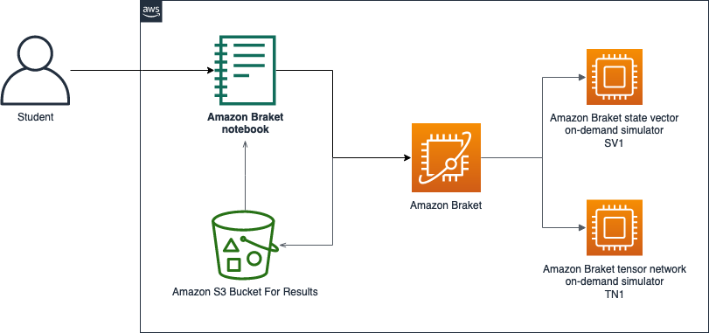

*Image description: The preceding diagram depicts the data flow from an external user to an Amazon Braket notebook instance, where the tasks for Amazon Braket are defined. These task definitions then get sent to the Amazon Braket service API for processing on the Amazon Braket tensor network on-demand simulator and state vector simulator. After the Amazon Braket API and simulator has processed your task, Amazon Braket returns the results to an Amazon S3 Bucket*

The following list details the major resources in the diagram:

* Amazon Braket notebook instance
* Amazon Braket Service
* Amazon Braket tensor network on-demand simulator
* Amazon Braket state vector on-demand simulator
* Amazon S3 bucket for results

**Start lab**

1. To launch the lab, at the top of the page, choose **Start lab**.

 You must wait for the provisioned AWS services to be ready before you can continue.

1. To open the lab, choose **Open Console**.

You are automatically signed in to the AWS Management Console in a new web browser tab.

**Do not change the Region unless instructed.**

COMMON SIGN-IN ERRORS

**Error: You must first sign out**

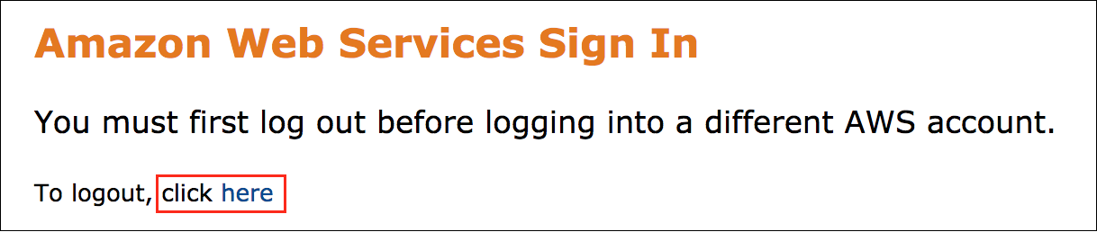

If you see the message, **You must first log out before logging into a different AWS account:**

* Choose the **click here** link.
* Close your **Amazon Web Services Sign In** web browser tab and return to your initial lab page.
* Choose **Open Console** again.

**Error: Choosing Start Lab has no effect**

In some cases, certain pop-up or script blocker web browser extensions might prevent the **Start Lab** button from working as intended. If you experience an issue starting the lab:

* Add the lab domain name to your pop-up or script blocker’s allow list or turn it off.
* Refresh the page and try again.

**Task 1: Explore the Quantum devices in the Amazon Braket service**

In this task you learn details about the various quantum computing devices offered by the Amazon Braket Service.

1. In the AWS Management Console, select the **Services** menu in the top left of the Amazon Management Console and choose **Amazon Braket**. It can be found in the **Quantum Technologies** section.
2. In the Navigation Pane to the left of the page, choose **Devices**.
3. Choose the link for each device listed in the **Devices** table and note the differences between each.

The devices with **Amazon Web Services** as the **Hardware provider** are the **AWS** quantum circuit simulators that will be used in the next task.

The remaining four devices are *third-party* hardware devices physically located around the world. These devices are used to perform quantum data processing…

 To learn more, visit [**Amazon Braket** Documentation](https://docs.aws.amazon.com/braket/latest/developerguide/what-is-braket.html)

**Task complete:** You have successfully learnt about various quantum computing devices offered by Amazon Braket.

**Task 2: Access the Amazon Braket notebook instance**

In this task you will access an Amazon Braket notbook instance with a pre-loaded notebook already in place. This notebook contains information and code on how to run a *hello-world* tutorial for running quantum circuits on the Amazon Quantum circuit simulators. Once the code for the simulators runs, the service automatically creates an **Amazon S3** bucket for the results of the quantum circuit simulators that you will explore in the next task.

1. Copy the **BraketNotebookInstanceURL** from the **AWS Console Information** in the left hand pane of the lab instructions and paste into a new tab of your browser.
2. Choose **1_Running_quantum_circuits_on_simulators.ipynb** in the list of files once the notebook opens.
3. Inside the Amazon Braket notebook you will press Shift + Enter or choose **Run** from the toolbar run code in the selected notebook cell.

**Note**: Do not proceed to the next step until all blocks in the **Amazon Braket** notebook have been ran.

**Task complete:** You have successfully accessed the Braket notebook instance and ran a code to generate quantum circuit simulators.

**Task 3: View results of your first Quantum Circuit in S3**

In this task, you will access the results of the quantum circuit your created in the previous task by accessing objects stored in Amazon S3. As mentioned in the previous task, running tasks on the Quantum circuit devices automatically creates an **Amazon S3** bucket for storing results. These can be used in a variety of ways.

The results can be used within the notebook itself to produce additional visualization of the data. These results can also be sent to a service like **Amazon Comprehend** to be further characterized.

1. Return to the **AWS Management Console**.
2. Select the **Services** menu in the top left of the page and search for **S3**. It can be found in the **Storage** section.
3. Choose the **S3** service.
4. Choose the bucket that has a similar name to **amazon-braket-us-east-1-1231231234**.
5. Choose the **tasks/** prefix.
6. Choose one of the two results prefixes. They will be task IDs for the state vector simulator and the tensor network simulator.
7. Check the box next to **results.json** and choose the **Actions** drop-down.
8. Choose **Download as**.
9. Open the context (right-click) menu for the link in the box that pops up, and then choose **Save link as…**
10. Choose **save**.
11. Choose the downloaded file from the location you downloaded the **results.json** to and it should open in your browser.
12. Explore each section of the results:
    * braketSchemaHeader
    * measurements
    * resultTypes
    * measuredQubits
    * taskMetadata
    * additionalMetadata

**Task complete:** You have successfully accessed and analyzed the quantum circuit results.

**Conclusion**

You have successfully done the following:

* Explored the Quantum devices offered by the Amazon Braket service
* Created a quantum circuit with the Amazon quantum circuit simulators.
* Viewed results of the quantum circuit tasks stored in S3.

**End lab**

Follow these steps to close the console and end your lab.

1. Return to the **AWS Management Console**.
2. At the upper-right corner of the page, choose **AWSLabsUser**, and then choose **Sign out**.
3. Choose **End lab** and then confirm that you want to end your lab.

For more information about AWS Training and Certification, see [*https://aws.amazon.com/training/*](https://aws.amazon.com/training/).

*Your feedback is welcome and appreciated.*  
If you would like to share any feedback, suggestions, or corrections, please provide the details in our [*AWS Training and Certification Contact Form*](https://support.aws.amazon.com/#/contacts/aws-training).

**Additional Resources**

* For more information about how to use Amazon Braket, see [AWS Braket Documentation](https://docs.aws.amazon.com/braket/index.html).